Procurement and Contracts Department
AL-Nassr Football Club
Kingdom of Saudi Arabia

Request for Proposal (RFP) – Services

Project Name: | Catering Management and Consultancy
RFP Number: | RFP 00011
Issue Date: | 3/9/2024
Participation Notice | 5/9/2024
Bid Closing Date: | 10/9/2024

As a trusted industry service providor, you are invited to submit a proposal for any or all of the line items described in this RFP. For your proposal to be valid it must comply with all of the notes, bidding instructions and conditions stated in this RFP requires and be submitted on your company’s letterhead to the address stated below on or before the closing date stated above.

BID INSTRUCTIONS

Introduction

Al-Nassr FC (NFC), one of the premier football clubs in the Middle East, is seeking a qualified and experienced catering management partner to operate and manage the food and beverage (F&B) facilities at the club. The selected partner will be responsible for delivering a world-class dining experience that meets the diverse needs of our players, Staff, Club members.

As a club that prides itself on excellence both on and off the pitch, Al Nassr FC is committed to ensuring that our F&B services reflect the high standards we maintain throughout our request services. This Request for Proposal (RFP) outlines the requirements and expectations for potential partners who wish to be considered for this important role.

We invite all interested and capable catering service providers to review the following details and submit their proposals for consideration. The Service Providors must have International experience in the hospitality sector, sporting event industry, managing catering operations, operating stadiums, arenas or sports facilities.

Provider shall advise of their intention to bid, or not, by acknowledging this Resquest for proposal ( RFP) through email: Procurement@alnassr.sa
(within 2 days of receipt).

General Information

NFC will make payments based on the actual costs and expenses incurred for all food and beverage, contingent upon an approved budget and corresponding invoices.

NFC seeks the flexibility to select from a diverse range of menu options while upholding the highest standards of quality. This approach ensures that the F&B experience aligns with the players' specific needs and preferences, providing them with optimal nutrition and satisfaction.

The service provider must dedicate a team of professionals who bring a wealth of international experience and expertise to the table. This is crucial for maintaining exceptional service to the club and meeting the highest standards of excellence.

NFC will pay a monthly management fee for the full range of services provided. This fee covers strategic oversight, the expertise and experience of the senior management team both within and outside of the core team, quality control, and ongoing support to ensure that all aspects of the operation are managed effectively. The only profit for the service provider must be included in the management fee.

Pricing Structure

The service providor must provide separate estimates for:

Food&Beverage Costs: Approximate costs associated with the number of meals to be provided daily and beverage.

Labor Costs: Estimated costs related to the staffing required to deliver the services.

These costs are to be detailed separately from the management fee. Please include a comprehensive breakdown of all these components to ensure transparency and clarity in the overall pricing structure.
- Al Nassr FC requires the Catering Service Provider to establish a monthly management fee for the comprehensive range of services provided. This fee should encompass:
- Strategic oversight
- Profit
- Expertise and experience of the senior management team, including both core and external team members
- Quality control measures
- Ongoing support to ensure effective management of all operational aspects

- NFC will cover the gross salaries and accommodation of the catering team, however the service provider needs to ensure the club retains a dedicated, consistent, and highly skilled team at all time.

Service provider team of professionals bring a wealth of international experience and expertise to the table which is crucial for maintaining exceptional service to the club and meeting the highest standards of excellence.

NFC expects the selected service provider to start work on the project immediately. To support this, NFC is willing to cover certain project setup costs related to the F&B services, including but not only limited to food, beverage,rent, insurance, and payroll, before the initial operation begins. These costs should be provided as a one-time lump sum.

Currency
Pricing and quotes should be submitted in Saudi Riyals

Work Duration and Completion
Service Provider shall quote for the required services according to scope terms and logistics used to achieve the required work completion date(s) to the place of service required. Service Provider shall state the scope terms on which quoted price is based.
Service Provider shall indicate in his bid that the services offered meet all of the requirements; specifications and standards referenced in the RFP, or clearly list in detail any specific exceptions taken.

Bid Document

Service Provider shall provide his proposal by Forsah platform only (as PDF document and Excel Spreadsheet attachments) for organizations outside the Kingdom of Saudi Arabia. The un-priced copy of bid is necessary for technical evaluation purposes.
For submissions by Forsah platform the document name must contain the RFP number indicated in the RFP cover page and the bidder’s name.
Service Provider shall complete and submit with it’s bid the Bid Form (attached) in accordance with
the requirements.
All costs associated with the preparation of Service Provider bid (are) borne by the Service Provider.

General conditions of service purchase
In the event of a Service Purchase Order being awarded, it will be subjected to the attached terms and conditions. These are the standard clauses applicable to all scope terms unless otherwise stated.
If Service Provider does not have a copy of the listed attachment that forms part of the RFP, Service Provider shall contact AL-Nassr FC’s buyer named on the face sheet of this RFP to obtain such attachments.
Scope of Work

Introduction :
The catering management for Al Nassr FC’s F&B facility will be executed in two distinct phases to cater to the unique needs of our players and staff. Each phase will require a tailored approach to ensure that both groups receive high-quality, nutritious meals that support their daily activities and overall well-being.

Player catering: Focused on providing specialized meals and services for the players, taking into account their dietary requirements and training schedules. ( Approximately 55 buffet style or takeaway meals per day 6 days a week for 8 monthes ) starting from first of October.

The weekly menus will be designed by the first team's nutritionist in accordance with the training load, upcoming matches, and player data. Additionally, catering for matches at our club or stadium will encompass both buffet-style and takeaway options.

Employees catering: Dedicated to serving the club's staff, ensuring a variety of meal options that meet the diverse preferences and needs of our team members starting from first of November.
- Lunch or dinner meal buffet style for 150 empolyees five days a week for one year .
- All day coffee break and bakery for 150 emloyees 5 days a week for one year.

Service Days
- Primary Service:
Sunday to Thursday from 9 AM to 5 PM
- Extended Service:
Possibility of offering services on weekends, depending on club needs.
Meals Provided (2 sessions/daily pleayer catering)
- Breakfast & Lunch or Dinner
- Lunch & Breakfast or Dinner
- Dinner & Lunch or Breaksfast
Service Options
- Buffet Services
A variety of meal options served buffet-style, catering to different tastes and dietary preferences.
- Takeaway Service:
Convenient takeaway options for those who prefer to dine outside the facility.
Number of Meals per Day
The catering service is expected to prepare and serve around 55 meals per session daily, ensuring consistency in quality and portion size.

Team Composition
- Culinary Team:
A team of skilled chefs and kitchen staff responsible for menu planning, meal preparation, and maintaining food safety standards.
- Service Personnel:
Professional service staff dedicated to providing excellent customer service, including buffet setup, table service, and takeaway coordination.

It is expected that the appointed company will provide an experienced team to assist with the planning and delivery of all elements of catering.

Technical Drawings

BOH
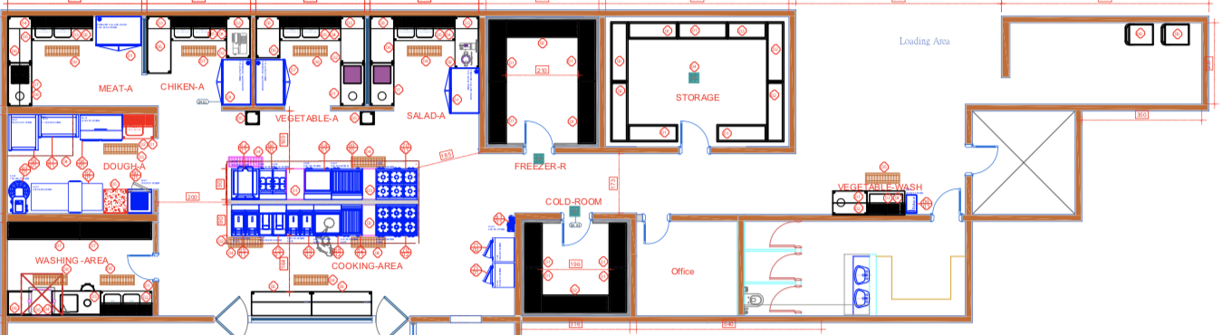

FOH (Buffet / WC)

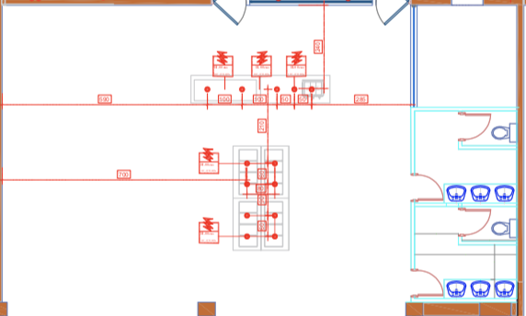

What the proposal should include:
To ensure a thorough evaluation process, Al Nassr FC requires all prospective catering management partners to submit a detailed proposal that addresses the following key elements. Your proposal should demonstrate your ability to meet the specific needs of NFC including the two-phase approach catering to both players and staff. We are looking for a partner who can deliver high-quality, nutritious meals while providing exceptional service.
Proposals should include, but are not limited to, the following:
- Include Information on your approach of the project

- Staff cost – define Organizational Chart and information on senior management

- Provide at least two menu samples

- Details on accounting and reporting structure

- Guarantee to provide a team with significant international experience starting to operate by the end of September

- Include at least 3 CVs of core team members who will work on the project: the project head, the nutritionist and the head chef

- Include details/references about a similar experience in sports industry

- Include systems used to ensure quality throughout the f&b operation

- Provide experience with sports enviroment you have operated in the Middle-East or anywhere else

- The Service Providor is responsible to provide all necessary FOH and BOH equipment to set up the opration and suggest a business solution

Main Deliverables:

Catering Management and Operations, as detailed in the Scope above.

Project Duration:

One year

Mandatory conditions

- Demonstrate experience in collaborating in internatioal sport events and luxury services.
- Showcase experience working alongside nutritionists for international league clubs and national football teams.
- Detail your responsibility and accountability for catering services, emphasizing Key Performance Indicators (KPIs) as set by the service providor to ensure optimal performance.

Reporting Requirements

All financial transactions must be documented and shared NFC. This ensures complete transparency, allowing the NFC to review all expenditures and verify the accuracy of the costs charged to NFC.

At the end of each month, NFCwill receive a detailed breakdown of all the costs incurred to deliver the F&B services for the players and the staff. This includes an itemized report of F&B costs, staff costs and any other expenses in relation to NFC, while scheduling meetings on a regular basis to evaluate service provider performance, risk management,review the player’s satisfaction, discuss any outstanding issue,
enhance coordination in order to update the budget.

Conclusion

The service providor must demonstrate their ability to offer superior quality service with innovation, responsiveness, and a strong commitment to the service providor’s principles. The ability to effectively cater to the specific needs of the players will be critical for successful collaboration

Note :
- List of exsiting equipments is attached, any addiotional tools or equipment must be provided by vendor.
- All prices and addtional expenses should be reflected on the pricing sheet.

Pricing sheet
Section B |  | Employee Catering
Meal | Qty per day |  | Unit | Unit Price | Total
Lunch or Dinner | 150 Employees |  | Monthly
All-day coffee break and bakery | 150 Employees |  | Monthly
Management fee | 12 Months |  | Monthly
Total
Vat
Total including Vat

Section A |  | Player Catering
Meal | Qty per day |  | Unit | Unit Price | Total
Breakfast | 55 Player |  | Monthly
Lunch or Dinner | 55 Player |  | Monthly
Snack | 55 Player |  | Monthly
Management fee | 8 Months |  | Monthly
Total
Vat
Total including Vat

 | Unit Price | Total
Total Section A and B
Vat
Total include Vat

Evaluation criteria

Technical evaluation | Score
Experience in sport industry | 20%
Team experience | 15%
Approach | 15%
Menu | 15%
Ongoing support | 15%
Quilty standard | 20%
Technical evaluation weight | 60%
Financial evaluation | 40%

